<page_start no = 1>
<sol_start id=1>
1. Astigmatism
<sol_end>

<sol_start id=2>
2. Repulsion
<sol_end>

<sol_start id=3>
3. Laterally inverted
<sol_end>

<sol_start id=4>
4. Babr the image of fish.
<sol_end>

<sol_start id=5>
5. The focal length of the lens =
So,
The lens is converging or convex lens.
<sol_end>

<sol_start id=6>
6. We know
Given, I = 5A, t = 30 minutes
q = I × t
= 5 × 30 × 60 c
= 150 × 60 c
= 9000 c
<sol_end>

<sol_start id=7>
7. Circuit symbol of five important components are –
(1) 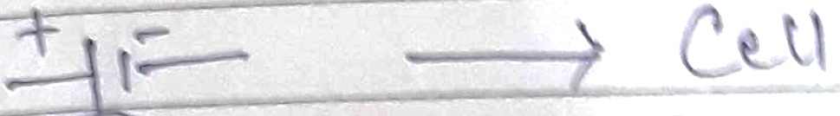
(2) 
(3) 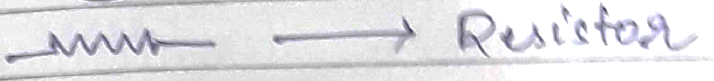
(4)
(5)
(6)
(7)
(8) 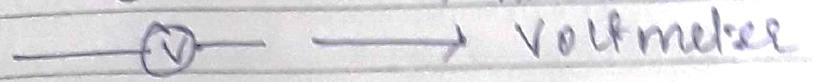
<sol_end>
<page_end>

<page_start no = 2>
<sol_start id=8>
8. Given : Lens nature is convex
Focal length = +12 cm
h_{o} = 5 cm
Object distance = –20 cm
Using lens, formula
Or,
Or
Or
Or,
Or → image distance
Size of image →
Or,
Or
Or
Hence, the nature of image is real, inverted and magnified.
<sol_end>

<sol_start id=9>
9. The charge is to be moved from higher potential to lower potential, i.e. 10v →5v.
Or
Or,
Or 5q_{o}, 5j
Or,
<sol_end>
<page_end>

<page_start no = 3>
<sol_start id=10>
<sub_id = 1>
10. PART-I
Pole : it is a geometrical centre of the reflecting surface. It is represented by letter P.
Radius of curvature : The radius of the sphere of which the mirror is a part of.
Principal Axis : The line joining the pole and centre of curvature of the mirror.
Principal focus : it is a point on the principal axis at which rays parallel to principal axis meet after reflection.
<sub_id end>
<sub_id = 2>
PART-II
The range of distance is in between the pole and the focus. i.e 0 cm to 20 cm.
Charectaristics of observed image
(i) Magnified image
(ii) Formed behind the mirror.
(iii) Virtual image
RAY DIAGRAM
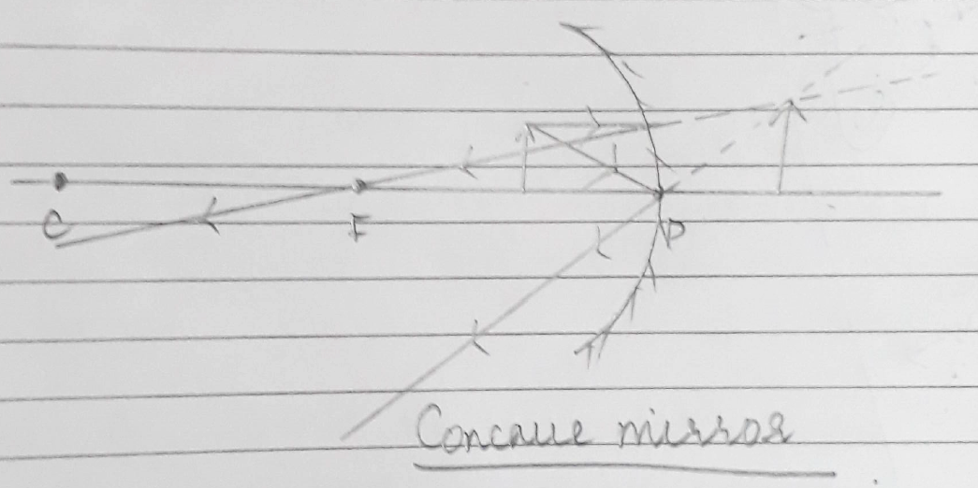
<sub_id end>
<sol_end>

<sol_start id=11>
11.(a) The sun appears reddish in the early morning as it is closer to the horizon and undergoes atmosphere it refraction.
(b) Power of accommodation of human eye means the ciliary muscle would focus the image on retina when the image is far or nearer.
(c) The least distance of distinct vision of human eye is 25 cm.
<sol_end>
<page_end>

